**CM12002 – Coursework 2: Automatic Disco System**

**Project Report**

**1.0. Introduction to the Problem Area**

The nightlife entertainment sector, particularly nightclubs and event spaces, has historically been characterized by high energy usage, with significant carbon footprints attributable to non-optimized lighting and sound systems. The challenge is compounded by the absence of systems that adapt to fluctuating occupancy levels, leading to a continuous and often unnecessary consumption of electricity. The motivation behind the development of an automatic disco system is to introduce a technological solution that not only addresses the issue of energy waste but also integrates seamlessly with the dynamic atmosphere that these venues aim to create. This system serves the dual purpose of enhancing environmental sustainability and providing an adaptable, responsive entertainment experience.

**1.1. Motivation for Selecting the Problem Area**

The selection of this problem area is motivated by the imperative to reduce operational costs for entertainment venues while adhering to environmental regulations and sustainability goals. By employing a system that automatically adjusts music based on real-time occupancy, energy consumption is going to be substantially lowered, thus contributing to both ecological and economic benefits. Additionally, the feature that moderates sound levels resonates with the growing awareness of hearing health, positioning the system as a health-conscious innovation. This project also reflects the broader societal shift towards intelligent automation.

**2.0. Literature and Technology Review**

**In this project, the concept of the Internet of Things (IoT) is central to achieving an intelligent and responsive nightclub environment. IoT describes devices with sensors, processing ability, software and other technologies that connect and exchange data with other devices and systems over the Internet or other communications networks [1]. Key components like infrared sensors for monitoring occupancy and microphones for noise level assessment are integral to this network. They provide critical real-time data, enabling the system to automatically adjust to varying conditions in the nightclub, such as modifying sound levels or managing the system’s use based on the number of attendees present. This approach exemplifies the utilization of IoT for enhancing operational efficiency and satisfying experience in dynamic public spaces.**

**The IoT plays a significant role in enhancing energy efficiency within buildings. Research has demonstrated that IoT can lead to substantial energy savings in commercial buildings. This technology, involving interconnected devices and sensors, is essential in optimizing energy use, especially in high-energy environments like nightclubs [2, 3].**

**Sound management is of paramount importance in such settings, due to the health implications of prolonged exposure to high noise levels. Studies show that excessive noise in nightclubs can lead to noise-induced hearing loss. Regulations require sound levels in work environments to be controlled, but nightclub attendees are often unaware of the risks associated with high noise levels [4, 5]. Implementing automated volume control systems in nightclubs is therefore crucial for protecting the health of the customers.**

**3.0. Development Process**

**3.1 Preparation Phase**

**Before commencing to work on the project, multiple meetings were organized with the intent to allocate responsibilities and come up with a plan. After a certain number of features and concrete implementation were unanimously agreed on, it was decided that the group would split up in pairs. Each pair took on a share of workload, which then got split between the two individuals in each group. Such atomisation allowed for efficient communication and productive workflow.**

**3.2. Hardware Development & Future Hardware Improvements**

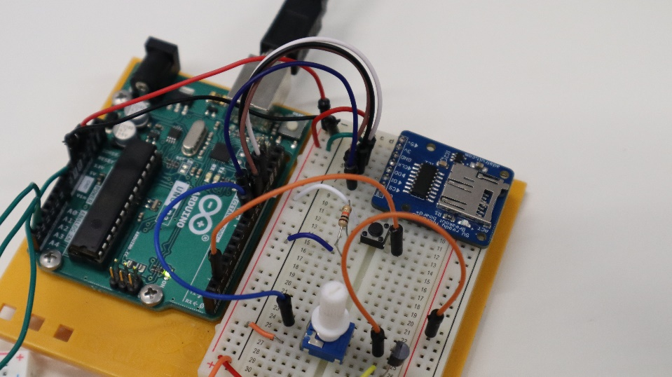The system consists of three Arduino boards: two "slave" boards and one "master". However, in order to work autonomously each group was allocated one slave and one master, with the idea that two masters will be merged together later on. The master is the control board that would be located in the club's DJ booth (see "Master", fig. 1). Initially, it was supposed to have five components: a speaker outside the booth, pause/pause button, manual volume control, SD card reader and an LCD screen showing the current volume level. However, it was later realised that the LCD screen could not be accommodated on the master board due to a lack of space, hence it was moved to one of the slave boards (see "Slave 1", fig. 1). The same slave board also has an array of LEDs representing the lighting ("disco") system, and a microphone for monitoring noise level. The second slave (see "Slave 2", fig. 1) has two infrared sensors that count the number of people in the room — one at the entrance and one at the exit.

Enabling the master to read “.wav” files from the SD card and to output these via the speaker required developing an understanding of the Micro-SD Breakout board [6]. The audio files must satisfy a tight set of requirements: they must be mono, have a sample rate of 16.0kHz and a bit depth of 8 bits. Converting the .wav files to this format proved difficult and significantly lowered the quality of the audio. As a result, this practise may not be suitable for real-world use. Given more time, an alternative such as USB flash memory would be considered. Early in development, it became apparent that the digital pins were not providing the speaker with enough current to output the desired volume level. Resolving this issue required implementing a transistor, connecting the 5v power supply (collector) to the speaker (emitter) via a digital pin (base), which increased the current. Moreover, a potentiometer was attached to the base input enabling the user to increase and decrease the volume manually. This is more effective than using the volume method provided by the TMRpcm library because it keeps the code complexity to a minimum.

A number of hurdles were encountered during each slave’s hardware development. Research revealed that electrical noise could disrupt the audio signal which the microphone, attached to Slave 1 (fig. 1), needs to pick up [5]. Hence, it was connected to the 3.3v power supply to mitigate noise problems and because this provides a more accurate depiction of the frequencies being picked up than the 5v power supply.

***Discuss communication method***

**3.3. Software Development & Future Software Improvements**

**The SPI, SD and TMRpcm libraries, amongst others, are required to communicate with and play .wav files from the** Micro-SD Breakout board. Implementing the audio functionality required extensive research to develop an understanding of these. [8, 9, 10] Furthermore, storing the “.wav” filenames raised scope problems because it was initially achieved using a list initialised in the “setup()” function. However, this resulted in it being outside the scope of the “loop()” function. This problem was solved by establishing the length of the list in the “setup()” function and using this to create a new list when a filename required accessing. The Master receives volume readings from Slave 1 (fig. 1) via I2C communication. However, minimising the number of bits transferred enables effective distribution of resources, such as time and processing power. Consequently, the Master only requests volume readings every five seconds and achieves this without delaying execution by making use of the “millis()” function.

Originally, the Master was intended to increase and decrease the volume depending on the data received from Slave 1. However, testing revealed that the size of the components means that the microphone fails to pick up music from the speaker unless they are in close proximity. The Master would often maximise the volume beyond safe levels and thus its ability to increase the volume was removed. In future, we would utilise more powerful components which allow us to effectively re-implement this feature.

Additionally, the microphone, attached to Slave 1 (fig. 1), produces an analogue value corresponding to the electrical signal produced by the change in capacitance caused by soundwaves as they hit the diaphragm of the microphone. [11] To convert this electrical signal to the amplitude of the soundwave, Slave 1 (fig. 1) calculates the difference between the maximum and minimum voltage detected over a short period.

**4.0. Final Implementation**

**5.0. Conclusion**

**6.0. References**

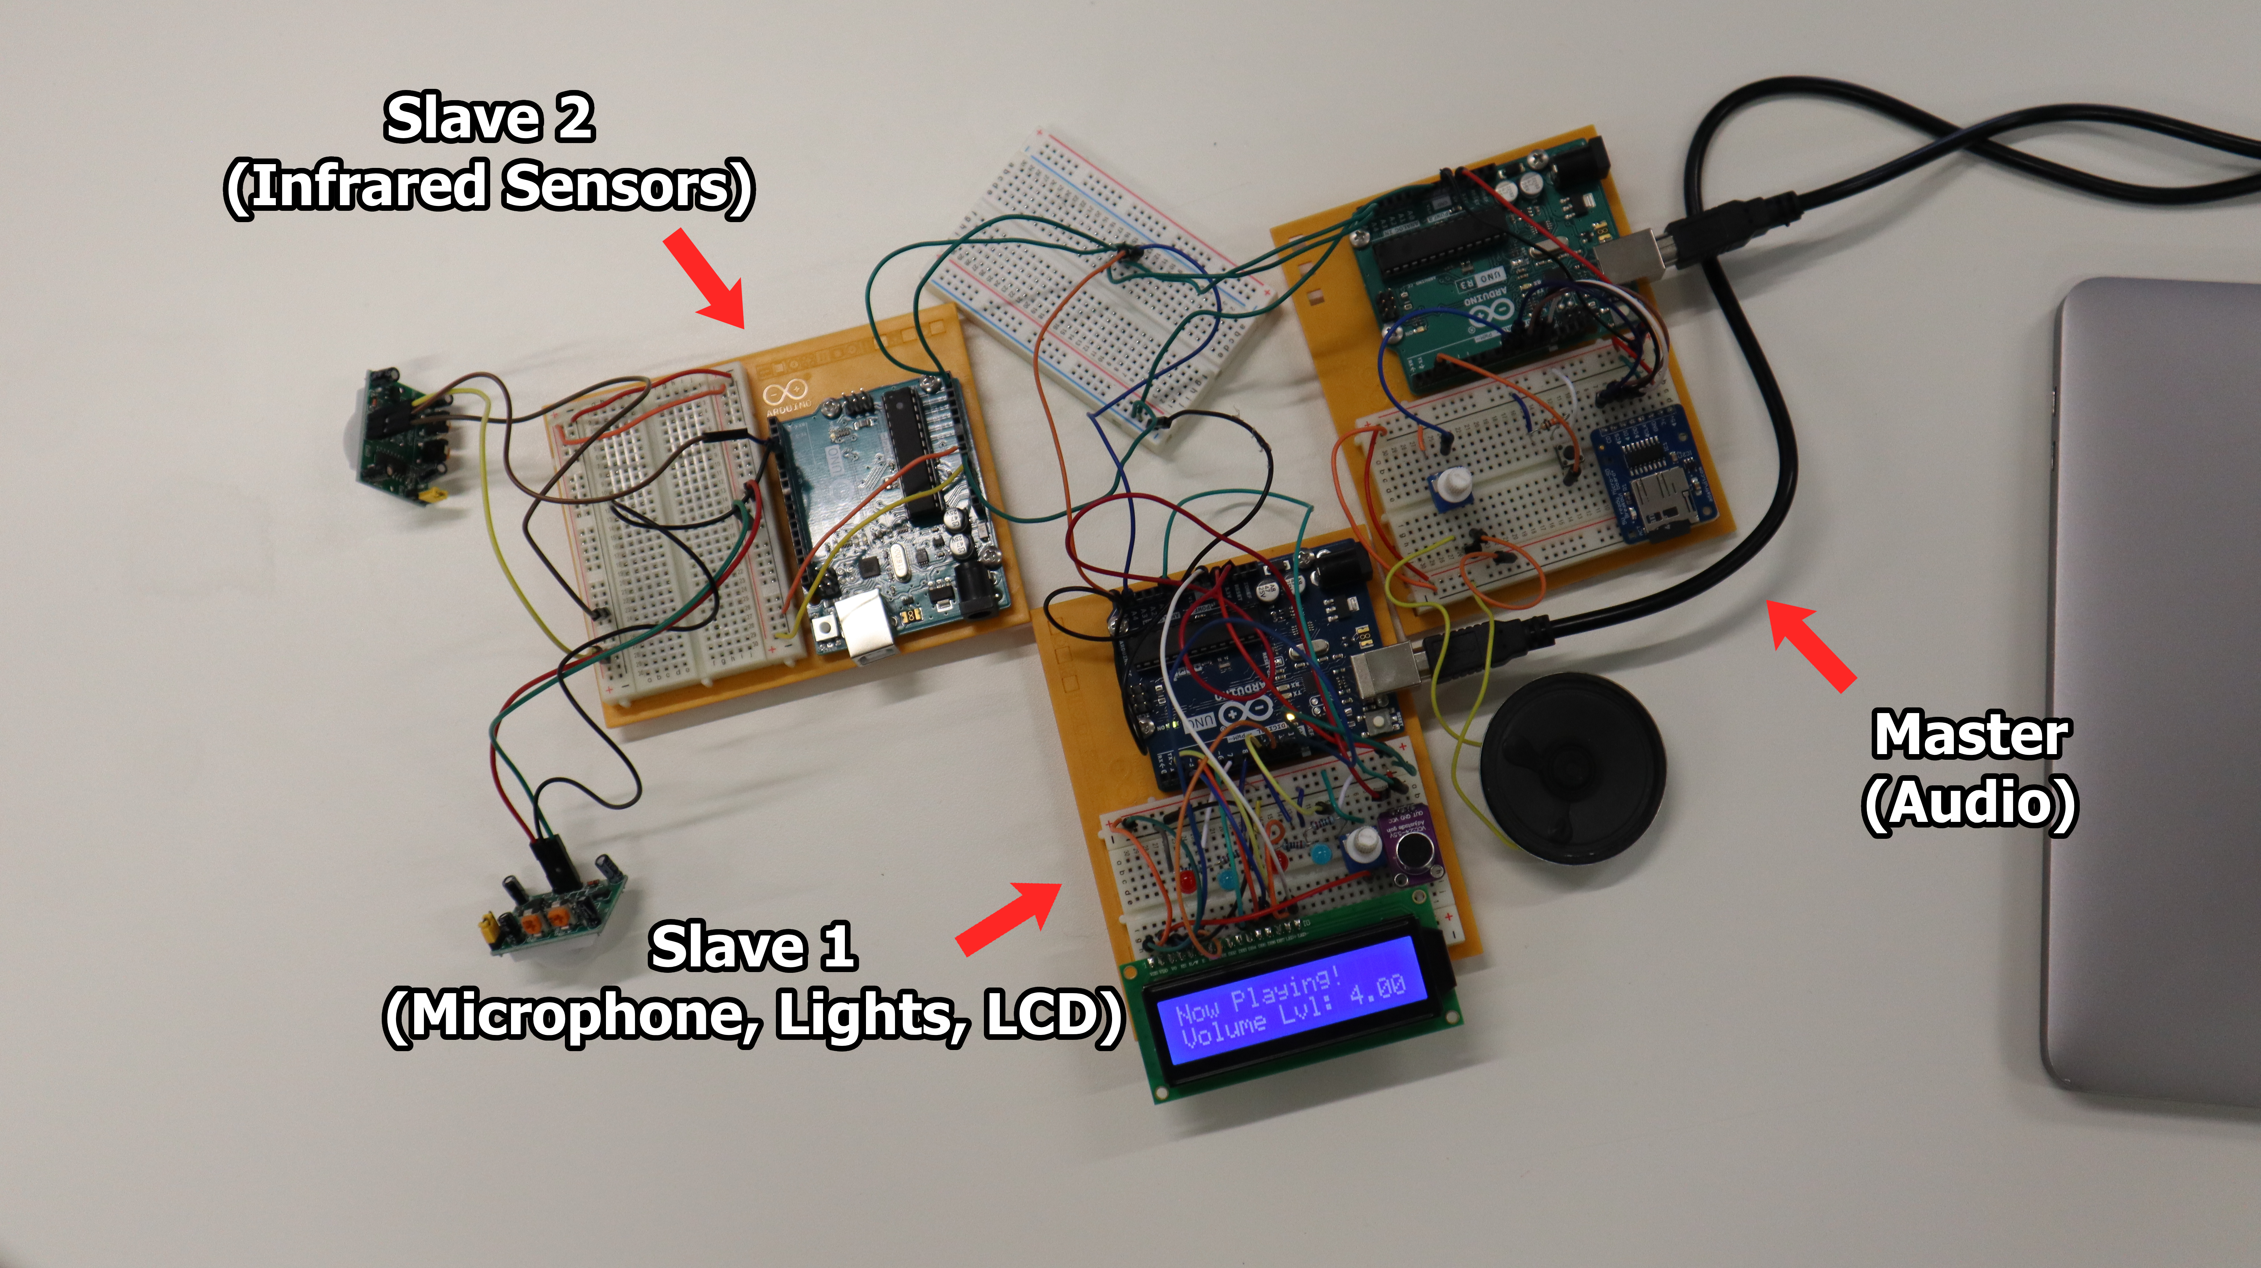**[1] “Internet of things”, Wikipedia, Available from: https://en.wikipedia.org/wiki/Internet_of_things [Accessed 5 December 2023].**

**[2] “Investigating energy savings when using IoT devices in buildings: a case study in the UK”, 2022 European Conference on Computing in Construction. Available from: https://www.researchgate.net/publication/362225733 [Accessed 5 December 2023].**

[3] “Integration of IoT in building energy infrastructure: A critical review”, ScienceDirect. Available from: https://www.sciencedirect.com/science/article/pii/S1877050923002971 [Accessed 5 December 2023].

**[4] “Excessive noise levels in nightclubs may cause noise-induced hearing loss”, Cambridge Core Blog, 2014. Available from: https://www.cambridge.org/core/blog/2014/02/25/turn-down-the-volume-an-examination-of-the-effects-of-nightclubs-on-hearing/ [Accessed 5 December 2023].**

[5] “Noise Levels in Nightclubs May Increase Risk of Hearing Loss”, AOC, 2016. Available from: http://www.aocphysicians.com/blog/noise-levels-in-nightclubs-may-increase-risk-of-hearing-loss [Accessed 5 December 2023].

[6] “Micro SD Card Breakout Board Tutorial”, Adafruit Ind., New York, 2023. Available from: <https://cdn-learn.adafruit.com/downloads/pdf/adafruit-micro-sd-breakout-board-card-tutorial.pdf> [Accessed 5 December 2023].

[7] “MAX4466 Microphone Preamplifier Module”, Proto Supplies, 2023. Available from: <https://protosupplies.com/product/max4466-microphone-preamplifier-module/> [Accessed 5 December 2023]

[8] “Arduino & Serial Peripheral Interface (SPI)”, Arduino, 2023. Available from: <https://docs.arduino.cc/learn/communication/spi> [Accessed 5 December 2023]

[9] “SD”, Arduino, 2023. Available from: <https://github.com/arduino-libraries/SD> [Accessed 5 December 2023]

[10] “TMRpcm”, TMRh20, 2023. Available from: <https://github.com/TMRh20/TMRpcm> [Accessed 5 December 2023]

[11] Mitchell, G., “How does a microphone pick up sounds?”, BBC Science Focus. Available from: <https://www.sciencefocus.com/science/how-does-a-microphone-pick-up-sounds> [Accessed 5 December 2023]